**Thermal Break End Cap RFA**

**Product**

* Thermal break end caps for Stellar Doors and All Seasons thermal extrusions.
* Replaces the taping process.
* Faster than tape by 69.73% and can be assembled at any point after powder coating.

**Reason**

A time study on the Te-Rapa Thermal Break found that 27% of the time goes into machine preparation such as purging, taping, prepping metal, manually loosening rollers, setting the computer, holding the buttons, releasing the buttons, setting rollers, setting the nozzle, test fitting the first piece, lifting it back, and then pouring the first piece. During this time the machine is cleared generally till the table is full. The thermal team spend on average 10 minutes preparing the batches of metal. This is because the team leader has to vacate the machine and get on a forklift to sort out the next batch of metal. Because they have metal drying on the conveyor table getting ready to be cut, it is seen as a productive to sort the metal out while the thermal is curing.

Once the metal has been prepared, the machine is able to process 10.3 metres per minute of metal. What delays the process is the frequency the machine has to be set up. During 5 hours and 10 minutes and 46 seconds, the machine was set up 28 times. The machine on average spend 4 minutes and 41 seconds getting set up which is an average of 2:11:8 over this duration. The machine was working for a total of 46:37 which tells us that the machine is not fully being utilized. The team spend 3:0:14 sorting the metal and 1:23:54 preparing the machine.

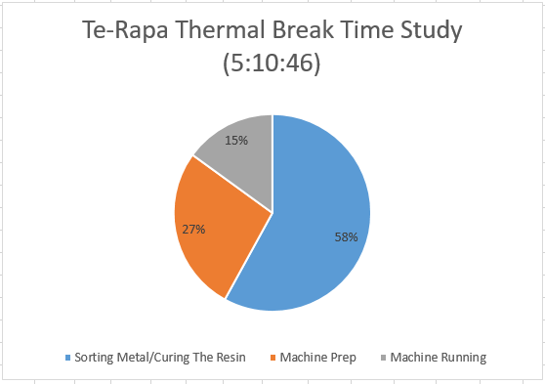

A task which was found to be inefficient was the taping process. The variation of metal make it time consuming to place tape onto every single extrusion and add to the machine prep time. The taping process involves a medium knowledgeable skill level on where and how to apply the tape in preparation for the thermal break. The solution proposed is to make end caps which can be inserted by anyone no matter the skill level in order to increase the speed and efficiency of the process.

**Options considered:**

The channel sizes for stellar doors have 5 different variations. The majority being 10.8 mm x 7 mm. All seasons Thermal channel sizes make up 10.8mm x 7mm and 10.8x6.8mm.

The two most common sizes make up to 77.53% of Te-Rapa thermal break sizes.

Proof of Concept Trials:

As a proof of concept the contour of the E13400 profile was traced and 3-D printed using ABS. 10 x E13400 pieces were extruded for a thermal cap trial using thermal caps for the specific profile. The pieced were powder coated and the plugs were inserted. Thermal paste was poured in the cavity.

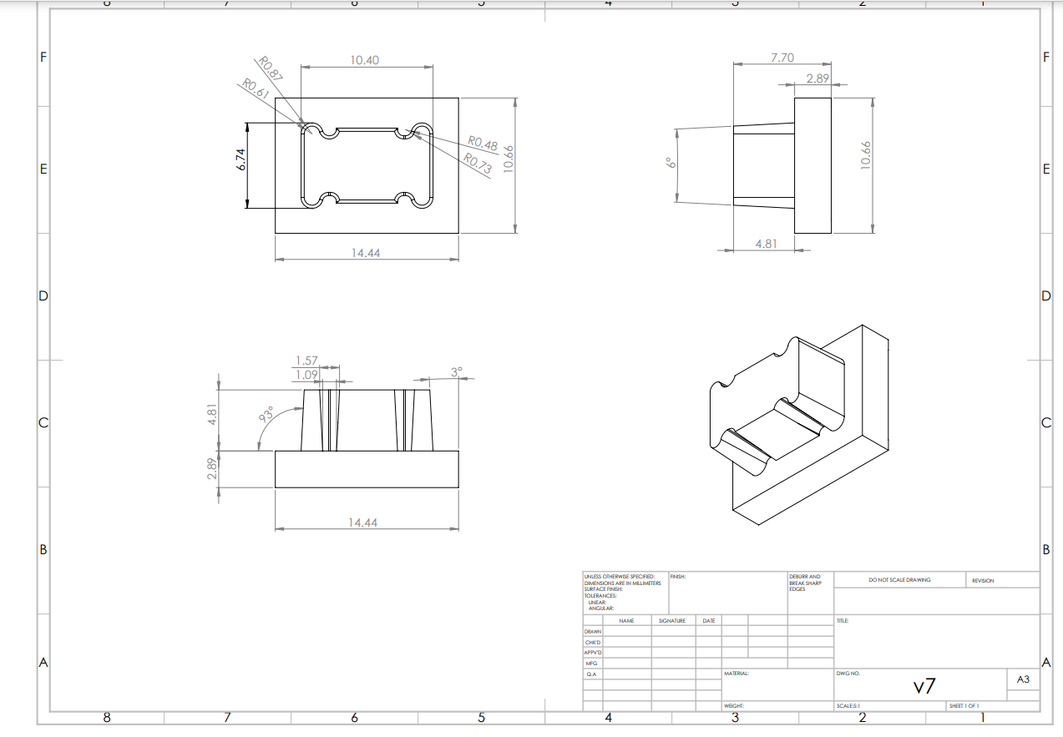

As a proof of concept trial it was successful but what was found is that there is a large variety of contours. If we were to go into full production then a universal cap that fit every stellar doors and All Seasons thermal cavity contours would be needed.

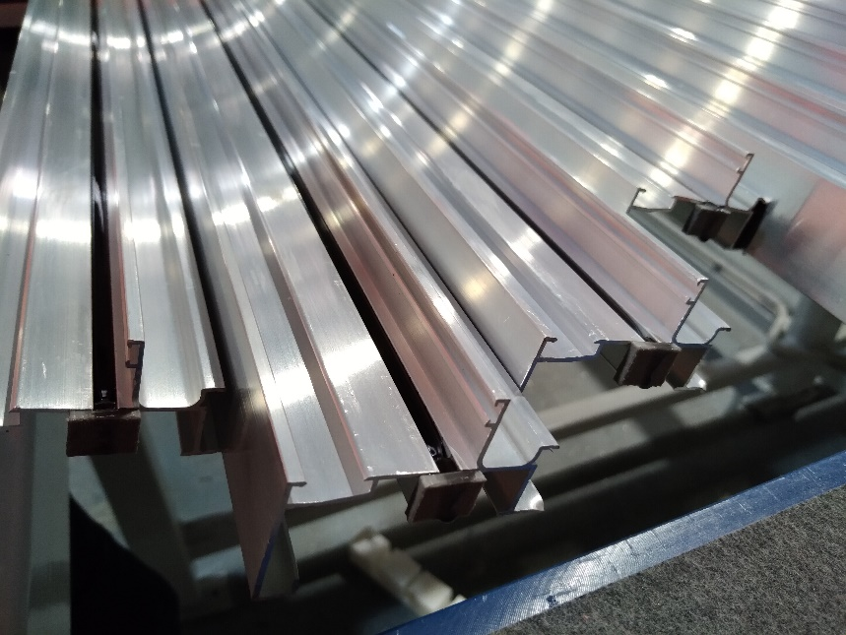  
*Extrusions trialled on E13400.*

Plastic:   
Due to the extrusion being cut and powder coated the thermal cavity has a wide variety of tolerances. Plastic is generally hard and has a high friction coefficient which requires more force inserting them. Plastic is not the best solution for this application. When 10 pieces were poured, the time taken to assemble the plug compared to the tape was taken.

The tape took an average of 4.79 seconds to assemble when the plastic PPE took 5.05 seconds to assemble. This design is 5.15% slower because the design depends on the tolerance of the metal and the powder coat finish. As a proof of concept it works and is successful. Ideally a universal piece made out of a more flexible material would be better.

Rubber – Santoprene:

Rubber happens to be more forgiving and able to meet the tolerance that thermal cavity has. Santoprene behaves like a rubber but can be processed like a thermoplastic. Santoprene has a cost reduction through manufacturing simplification, part weight reduction and has potential for recycling at the end of its life. Since the part is a one off application and non-re-usable due to the thermal paste being able to bond to the thermal cap, a cheaper solution will do.

A trial was undergone with pieces designed by Azon that had been previously used in Te-Rapa but stopped due to unknown reasons. The tape took an average of 4.79 seconds to assemble when the Azons’ Santoprene piece took 1.45 seconds to assemble. This is a 69.73% reduction in time.

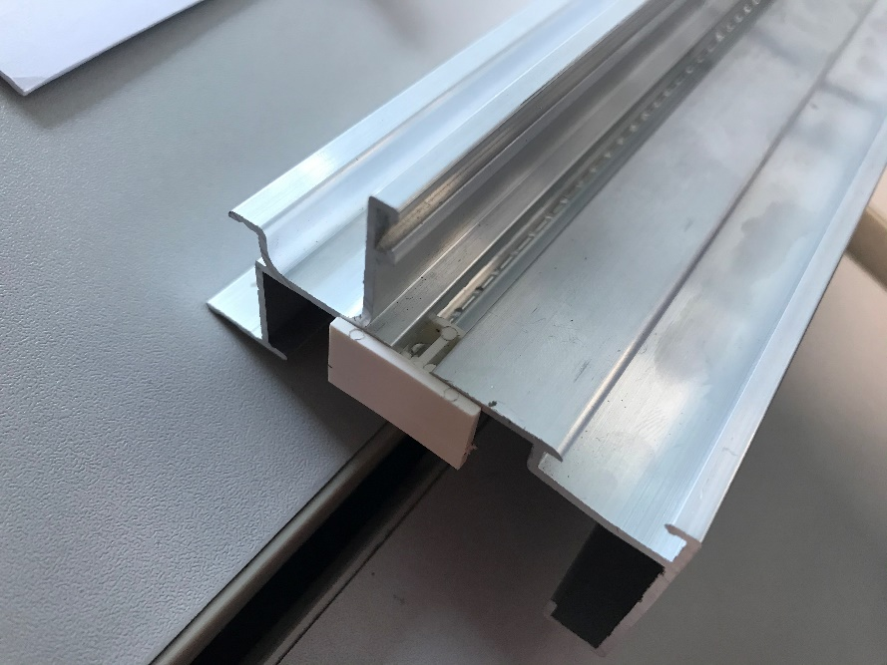

*Azons Santoprene thermal cap previously used.*

Plastic LDPE:

LDPE is a cheap alternative because it is able to withstand the temperatures and most chemicals and is easily recyclable. It is also forgiving and flexible and able to bend into the cavity. LDPE is the material choice and the option to peruse for this application.

**Risk Assessment**

* Tape being used instead of thermal caps – It is important to design the thermal caps so it provides a better alternative to tape and requires a simple understanding of assembly.
* Tape not assembled the correct way. Tape falls off during travel and vibrations if assembled anywhere else apart from thermal break.

**Health & Safety Assessment**

* Thermal caps difficult to fit – Workers taking of their gloves in order to insert them causing fingerprints and potential injuring from forcing them to fit. It is important to design it correctly for an easy fit for the assembler.

**Customer Driven**

Liquid thermal break offered in the all seasons and stellar doors extrusions is a unique thermally broken extrusion Altus offers its customers. Due to the volume almost doubling in capacity since January for stellar and all seasons, there is still a demand for it. Fabricators tend not to use the ends of extrusions and the last 50mm will be mitre cut and trimmed off having no significant impacts to the customer. The extrusion will be processed the same on the customers end.

**Capital Expenditure**

|  |  |  |
| --- | --- | --- |
| **Product** | **Company** | **Cost** |
| 1 x Tooling cost | Sharpshifter Engineering | $ |
|  | Sharpshifter  Engineering | $ |
| **Total** |  | **$** |

No extra engineering costs will be required after the initial payment.

**Financial Justification**

Reducing machine prep time/sorting time is a crucial to decrease the amount of dead time on the thermal break machine.

**Operational Justification**

Due to the volume increasing in Te-Rapa, areas that can be improved need to be addressed in order to meet future production volumes. With additions of thermal caps, the capping process can be done at any point after it has been powder coated at the VPL. Due to the simplified process, time is saved at the thermal break by reducing a step entirely in the prepping process.

**Volume**

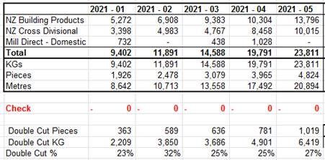

Pieces for 1 month  
(1926*2)-(363*4)= 3,126singles  
363*4=1,452doubles  
54,936 pieced per year

55,000 pieces per year needed from the mold